Result of Grad-CAM Visualization on Unseen Test Samples

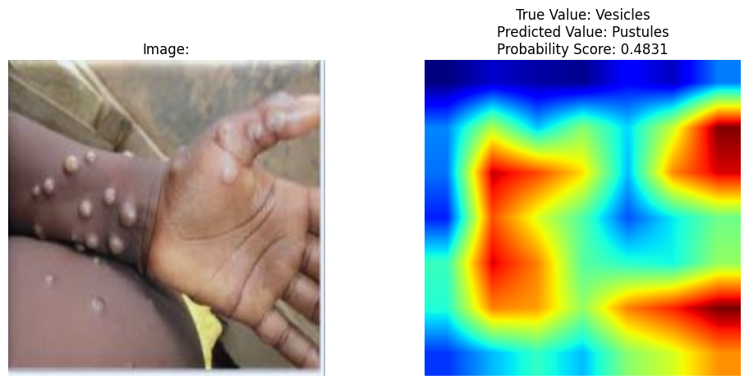
Figure xxx. Grad-CAM Explainability for Scabs Severity Level on Unseen Image

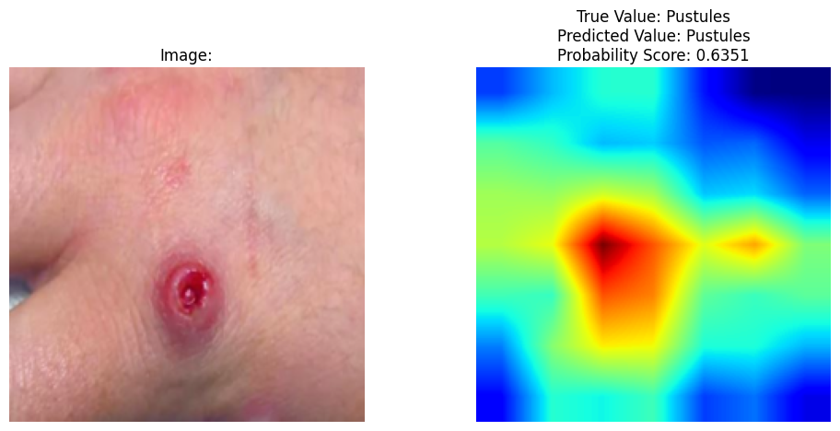
Figure xxx. Grad-CAM Explainability for Pustules Severity Level on Unseen Image

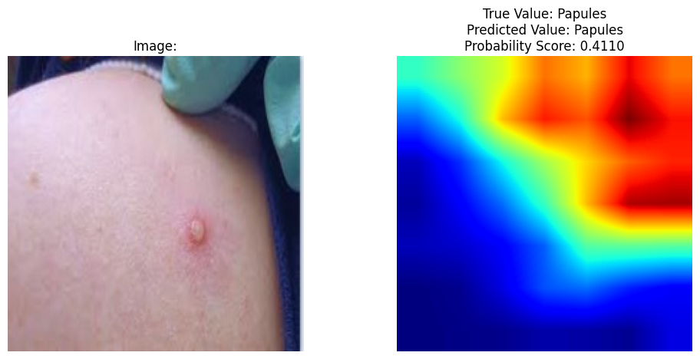
Figure xxx. Grad-CAM Explainability for Papules Severity Level on Unseen Image

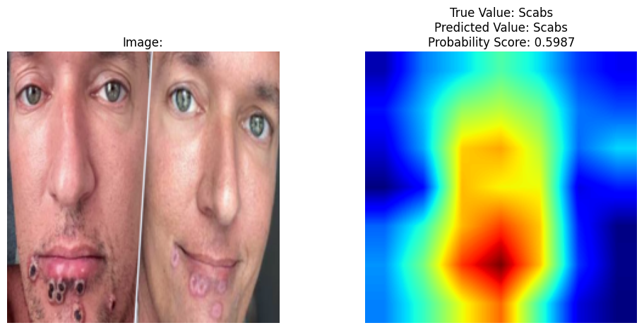
Figure xxx. Grad-CAM Explainability for Scabs Severity Level on Unseen Image

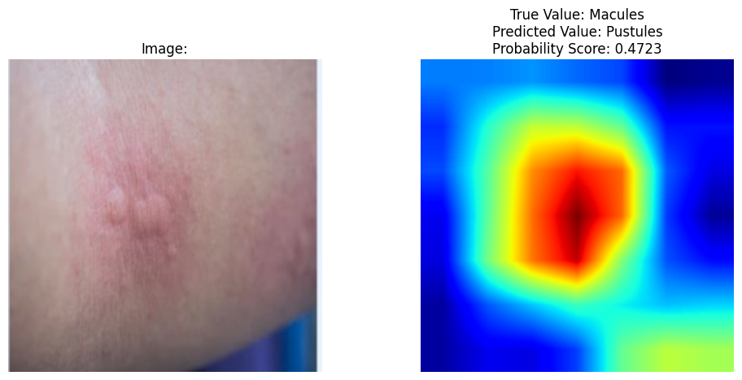
Figure xxx. Grad-CAM Explainability for Macules Severity Level on Unseen Image

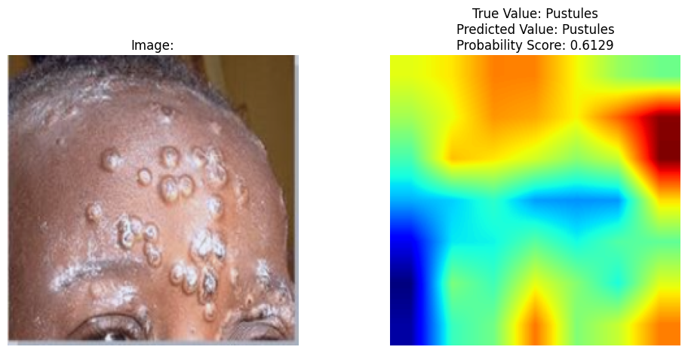
Figure xxx. Grad-CAM Explainability for Pustules Severity Level on Unseen Image

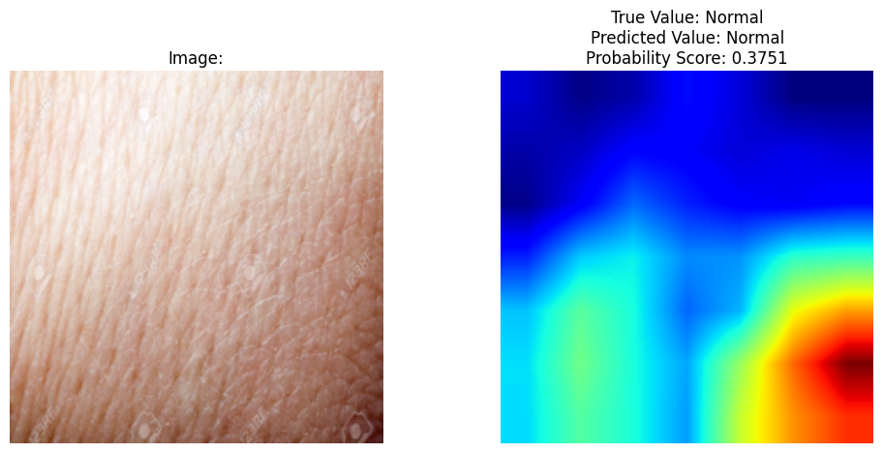
Figure xxx. Grad-CAM Explainability for Normal Skin Classification on Unseen Image

